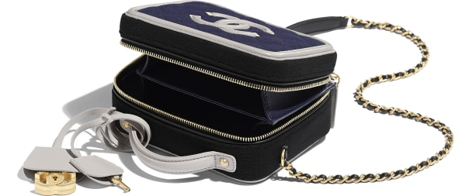

CHANEL-Small Vanity Case

CAN$4,725

COLOR : Navy Blue, Black & Gray  
SIZE : ONE SIZE  
IN STOCK

[Detail](http://127.0.0.1:60314/content/QJvlAtZJOAot1QAuAAAT/jtkUAuy/LeWQeJo/nvIHWZa/tdItJVf#collapse)

Jersey, Calfskin & Gold-Tone Metal

• 13 × 7 × 17 cm

• Reference: A93342 B01189 N4963

[CARE & COMPOSITION](http://127.0.0.1:60314/content/QJvlAtZJOAot1QAuAAAT/jtkUAuy/LeWQeJo/nvIHWZa/tdItJVf#collapse1)

• Leather

• Imported